Code and screen shots for converting a string of text into text displayed on the screen using sprites to display questions in the game.

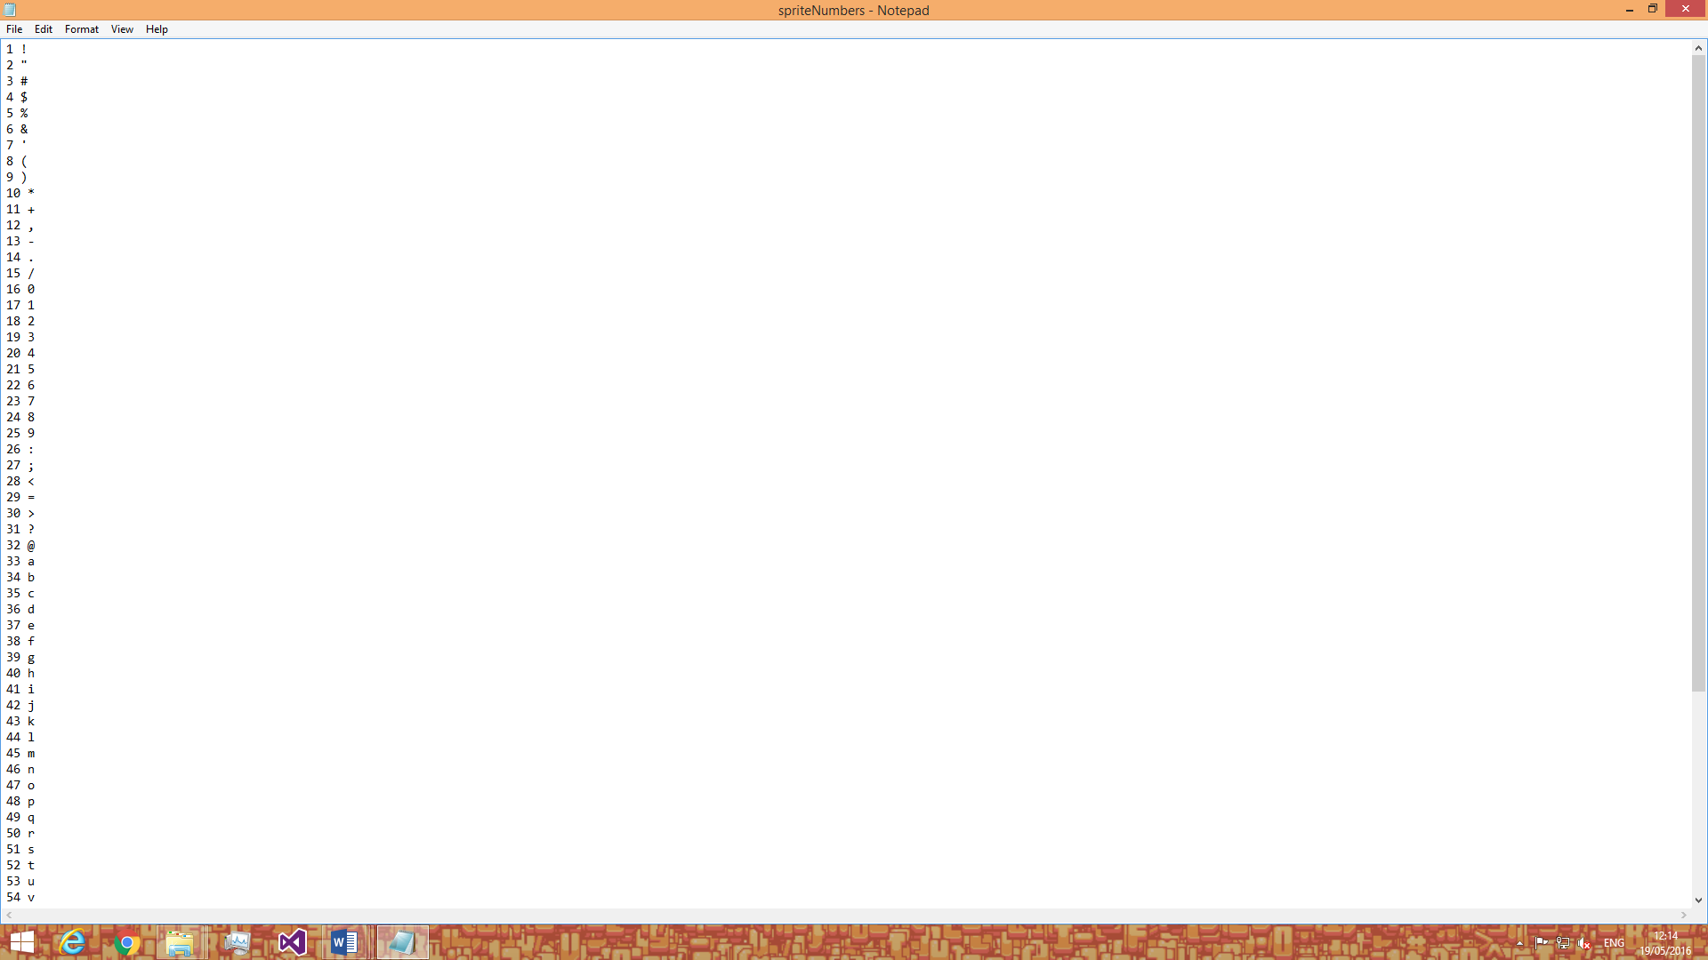

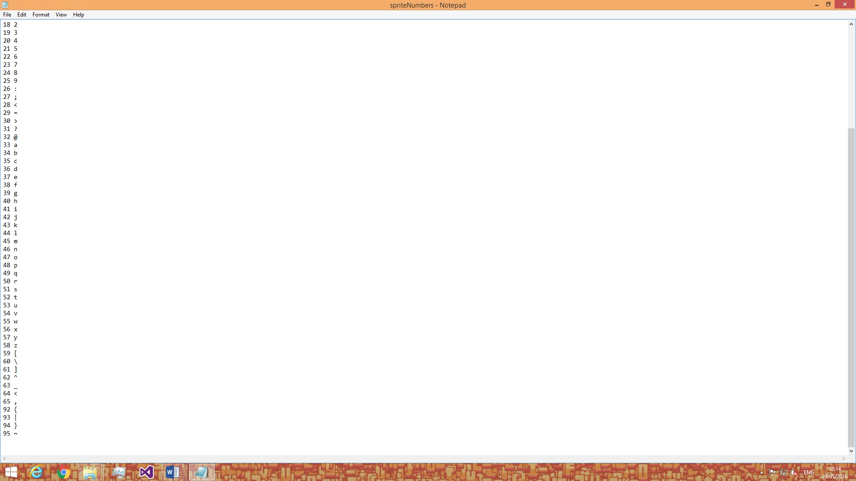

The screen shots above are what is inside the text file for the sprites and their matching key.

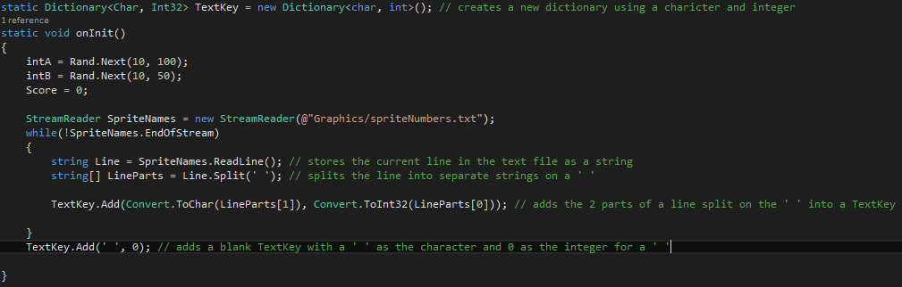

This screenshot shows the code for the dictionary Text Key being made and the values from a text file being put into the dictionary.

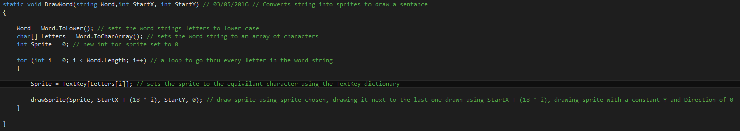

This screenshot shows the string inputted being converted to lower case, into an array of characters and then to its corresponding sprite and drawn next to the last sprite drawn at the inputted x and y

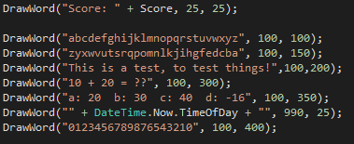

This screenshot shows the code to display what is in the screen show below.

